Fragment

* In Android, the Fragment is the part of Activity which represents a reusable portion of User Interface(UI) on the screen.
* A fragment defines and manages its own layout, has its own lifecycle, and can handle its own input events.
* That are flexible in nature and auto-adjustable based on the device screen size.
* Fragments cannot live on their own--they must be hosted by an Activity or another Fragment. It can be **Sub-Activity** as they are part of Activities.
* We can add or remove fragments in an activity while the activity is running.
* **<fragment>**tag is usedto insert the fragment in an android activity layout.

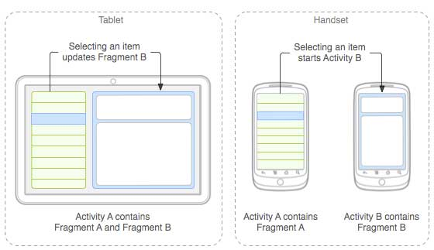

Multiple fragments can be added to one activity. This task can be carried out in 2 ways:

1. **Statically:** Explicitly mention the fragment in the XML file of the activity. This type of fragment can not be replaced during the run time.
2. **Dynamically:** **FragmentManager**is used to embed fragments with activities that enable the addition, deletion, or replacement of fragments at run time.

[FragmentManager](https://developer.android.com/reference/androidx/fragment/app/FragmentManager) is the class responsible for performing actions on your app's fragments, such as adding, removing, or replacing them, and adding them to the back stack

| Methods | Description |
| --- | --- |
| onAttach() | The very first method to be called when the fragment has been associated with the activity. This method executes only once during the lifetime of a fragment. |
| onCreate() | This method initializes the fragment by adding all the required attributes and components. |
| onCreateView() | System calls this method to create the user interface of the fragment. The root of the fragment’s layout is returned as the View component by this method to draw the UI. |
| onActivityCreated() | It indicates that the activity has been created in which the fragment exists. View hierarchy of the fragment also instantiated before this function call. |
| onStart() | The system invokes this method to make the fragment visible on the user’s device. |
| onResume() | This method is called to make the visible fragment interactive. |
| onPause() | It indicates that the user is leaving the fragment. System call this method to commit the changes made to the fragment. |
| onStop() | Method to terminate the functioning and visibility of fragment from the user’s screen. |
| onDestroyView() | System calls this method to clean up all kinds of resources as well as view hierarchy associated with the fragment. |
| onDestroy() | It is called to perform the final clean up of fragment’s state and its lifecycle. |
| onDetach() | The system executes this method to disassociate the fragment from its host activity. |

